Software Defined Networking.

## Traditional Networking

Once upon a time… there were computers. At the very beginning, they could not talk with one another. At [some point during the 1960s](https://en.wikipedia.org/wiki/Computer_network#History), the few people that would use them figured out that, for reasons that seem quite obvious today, connecting several computers could be a good idea. And so computer networks were created! For some decades, setting up a network would basically consist in plugging cables between pairs of devices; and to connect more than two hosts together on local networks, hubs or [switches](https://en.wikipedia.org/wiki/Network_switch) would be required. To connect several networks between them would be the task of routers.

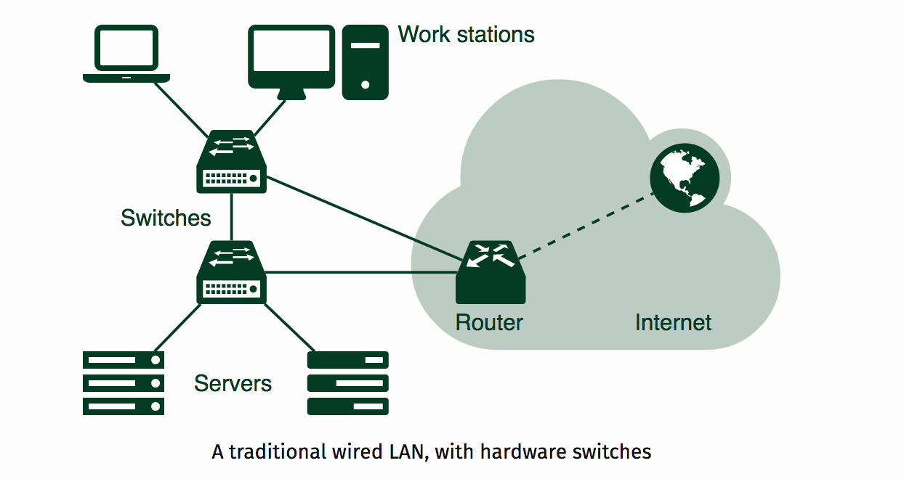

Actually, correctly setting up a network is way more complicated than that. This is why so many protocols have been invented and implemented over the years: making it run, and addressing the requirements in terms of stability, scalability, security, quality of service and so on… it could require quite a lot of skills and knowledge from the administrator. Nevertheless, it would come down to connecting different physical hosts together. Even since [wireless networks](https://en.wikipedia.org/wiki/Wireless_network) have been deployed, this has remained a basic principle.

## Software Defined Networking (SDN)

Since networks have been increasing a lot in size and in requirements, moving around hardware switches has become a burden. Even manually setting up individual software switches has become a complicated and error-prone task for companies running strongly virtualized environments along with large networks. This is where [Software Defined Networking](https://en.wikipedia.org/wiki/Software-defined_networking)—SDN for short—enters the game, in the early 2010s.

“SDN” is a bit like “cloud computing”: it is a trendy topic in computing, and it is often sold as a “miracle” solution to all network infrastructure problems. But beside marketing, it also corresponds to a new type of network architecture. “Software defined” does not mean that it only uses virtual switches instead of dedicated hardware (even if it mostly does): it refers to the fact that switches can be programmed. Their behavior is defined by a software configuration. Indeed, the main feature of SDN is that the switch control plane is decoupled from the data plane. What does this mean?

* The **control plane** is where the administration of the network takes place: it corresponds to the setting up of the packet processing rules, and from there to the establishment of the whole network switching policy.
* **Data plane** encompasses the application of those rules defined on control planes: this is the actual packet processing. When some packets require some particular, more complex processing, they can be handled to the control plane, where the decision regarding this packet will occur.

As a generic principle, the data plane must be very fast to handle a very high number of packets with simple rules so as to obtain a good bit rate in the network. By contrast, the control plane is slower. For legacy switches, the whole control and data planes would be tightly linked into a same hardware box. They would not be clearly delimited, and the switch would usually present a single setup interface. But virtual switches offer new possibilities: they make it doable to centralize the management of the switches and to remotely program them. The control plane is organized in such a way that switches take orders from a centralized controller in the network. This controller dynamically installs packet processing rules onto the switches, and receives and (slowly) handles exception packets when needed.

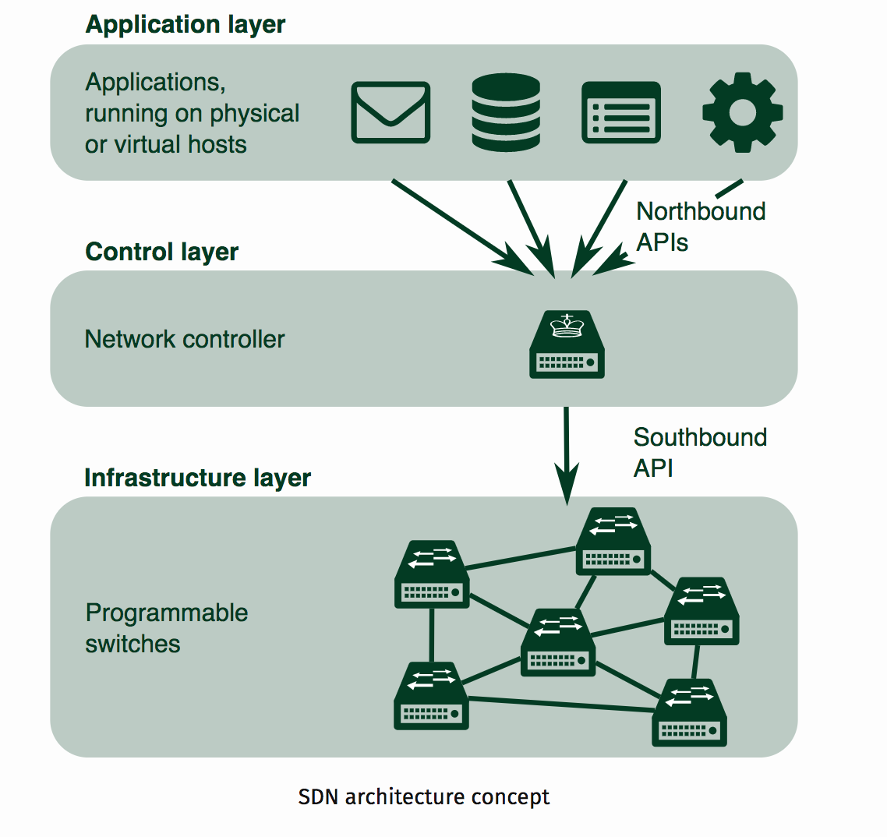

In the above diagram **the Control Layer/Plane will be ONOS** and the **Data plane/Infrastructure Layer will be simulate using Mininet**

**ONOS DIAGRAM (CONTROL LAYER/CONTROLLER):**

**-**

**BLUE SWITCHES IN THE ABOVE DIAGRAM WILL BE SIMULATED USING MININET**

## Setting up a virtual environment for ONOS and Mininet

**Configuring your ONOS VM:**

SSH into your VM via Putty or Terminal

ONOS is a Java based platform so you need to install java in your system. Use the snippet below to install java. You can copy paste the below commands all at once

sudo apt-get install software-properties-common -y && \

sudo add-apt-repository ppa:webupd8team/java -y && \

sudo apt-get update && \

echo "oracle-java8-installer shared/accepted-oracle-license-v1-1 select true" | sudo debconf-set-selections && \

sudo apt-get install oracle-java8-installer oracle-java8-set-default -y

**STEP 4**: Install Curl ( Look up what curl is?)

sudo apt-get install curl –y

**STEP 5**: Installation

Create directory in root file system named ‘opt’. If the directory exists, change directory to /opt and skip to step 6.

sudo mkdir /opt

cd /opt

**STEP 6**: Download the ONOS application using wget

sudo wget –c https://downloads.onosproject.org/release/onos-1.9.2.tar.gz

**STEP 7**: Unzip the package

sudo tar -xzf onos-1.9.2.tar.gz

**STEP 8**: Rename the extracted directory to “onos” from “onos-1.9.2”

**STEP 9**: Verify the ONOS works

sudo su

/opt/onos/bin/onos-service start

If everything is configured correctly you should see this

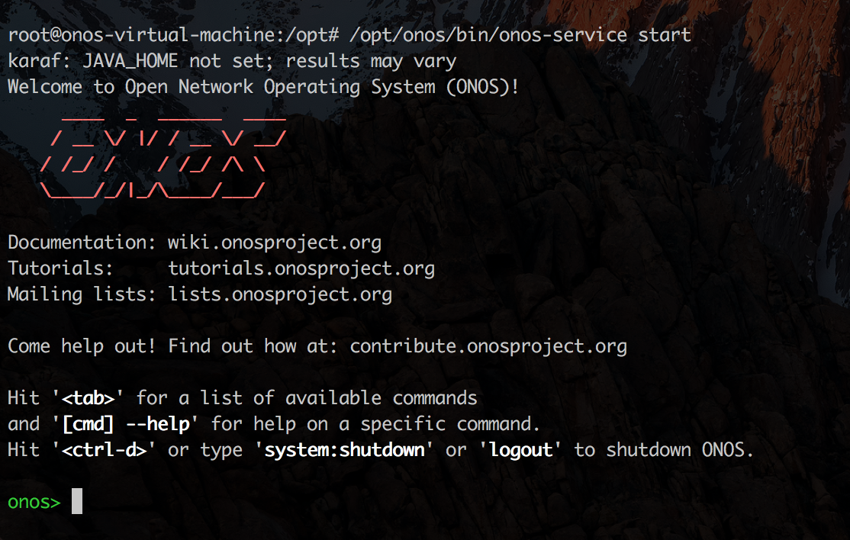

The above screenshot is your CLI for onos. To access the GUI, go to your browser and type

http://**XX.YY.WW.ZZ**:8181/onos/ui/index.html

Replace the bold text with your ONOS VM IP

Login**: onos** Password: **rocks**

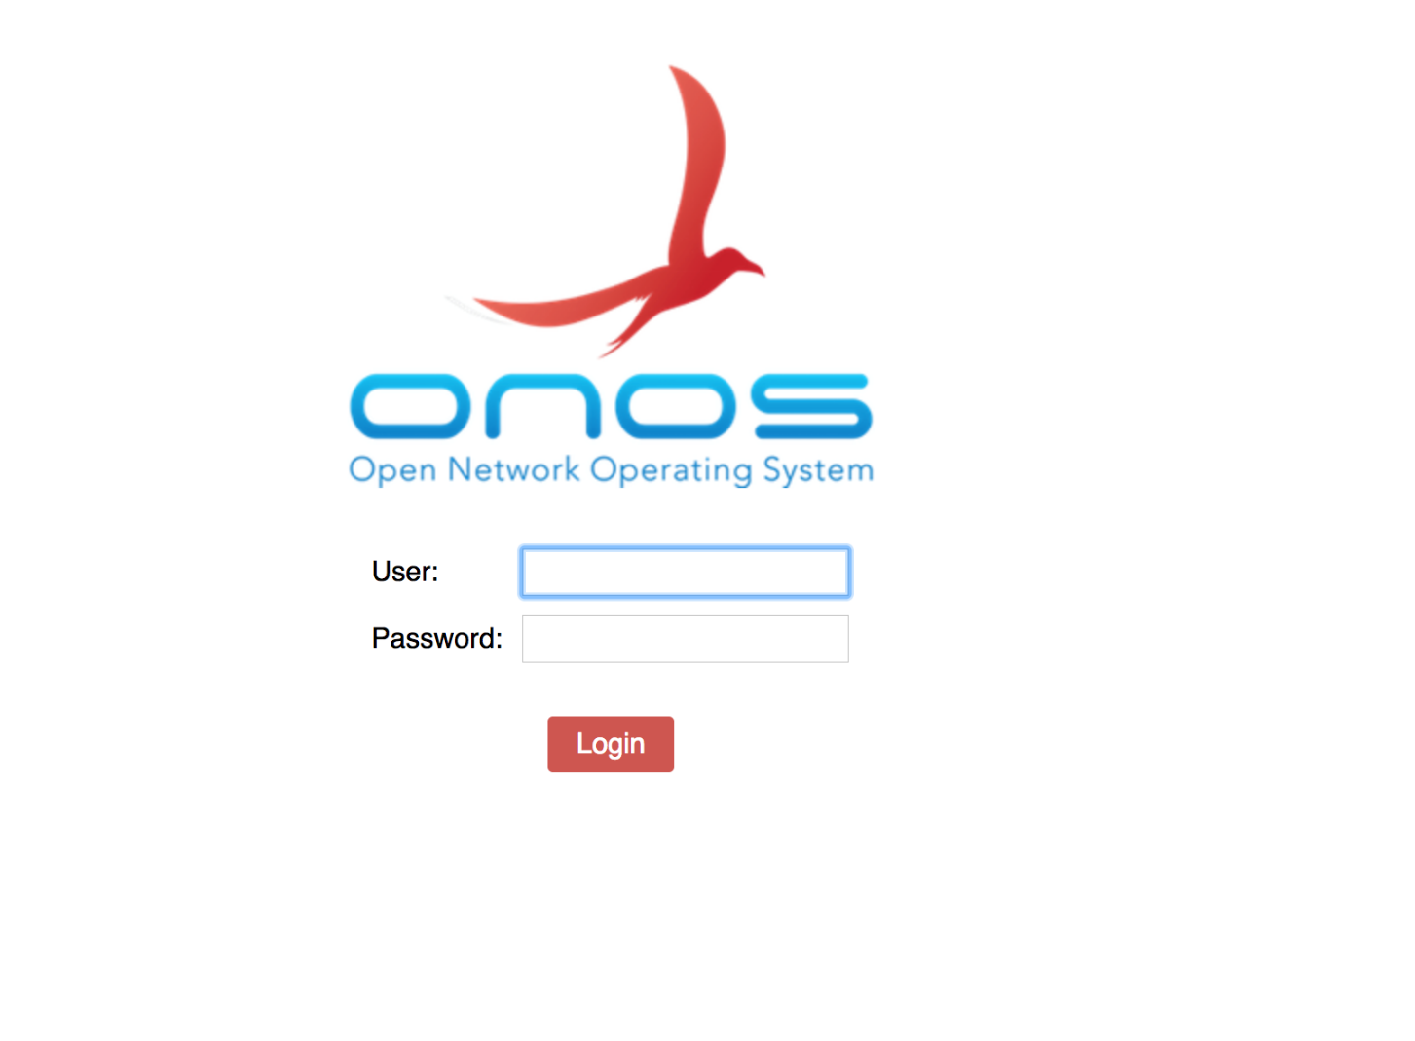

Navigate to the applications (see below screenshot) and make sure you have the following apps activated. Activated apps display a green tick mark next to it. It is pretty straight forward to activate these apps and It is your duty to find out how to activate these apps on your own.

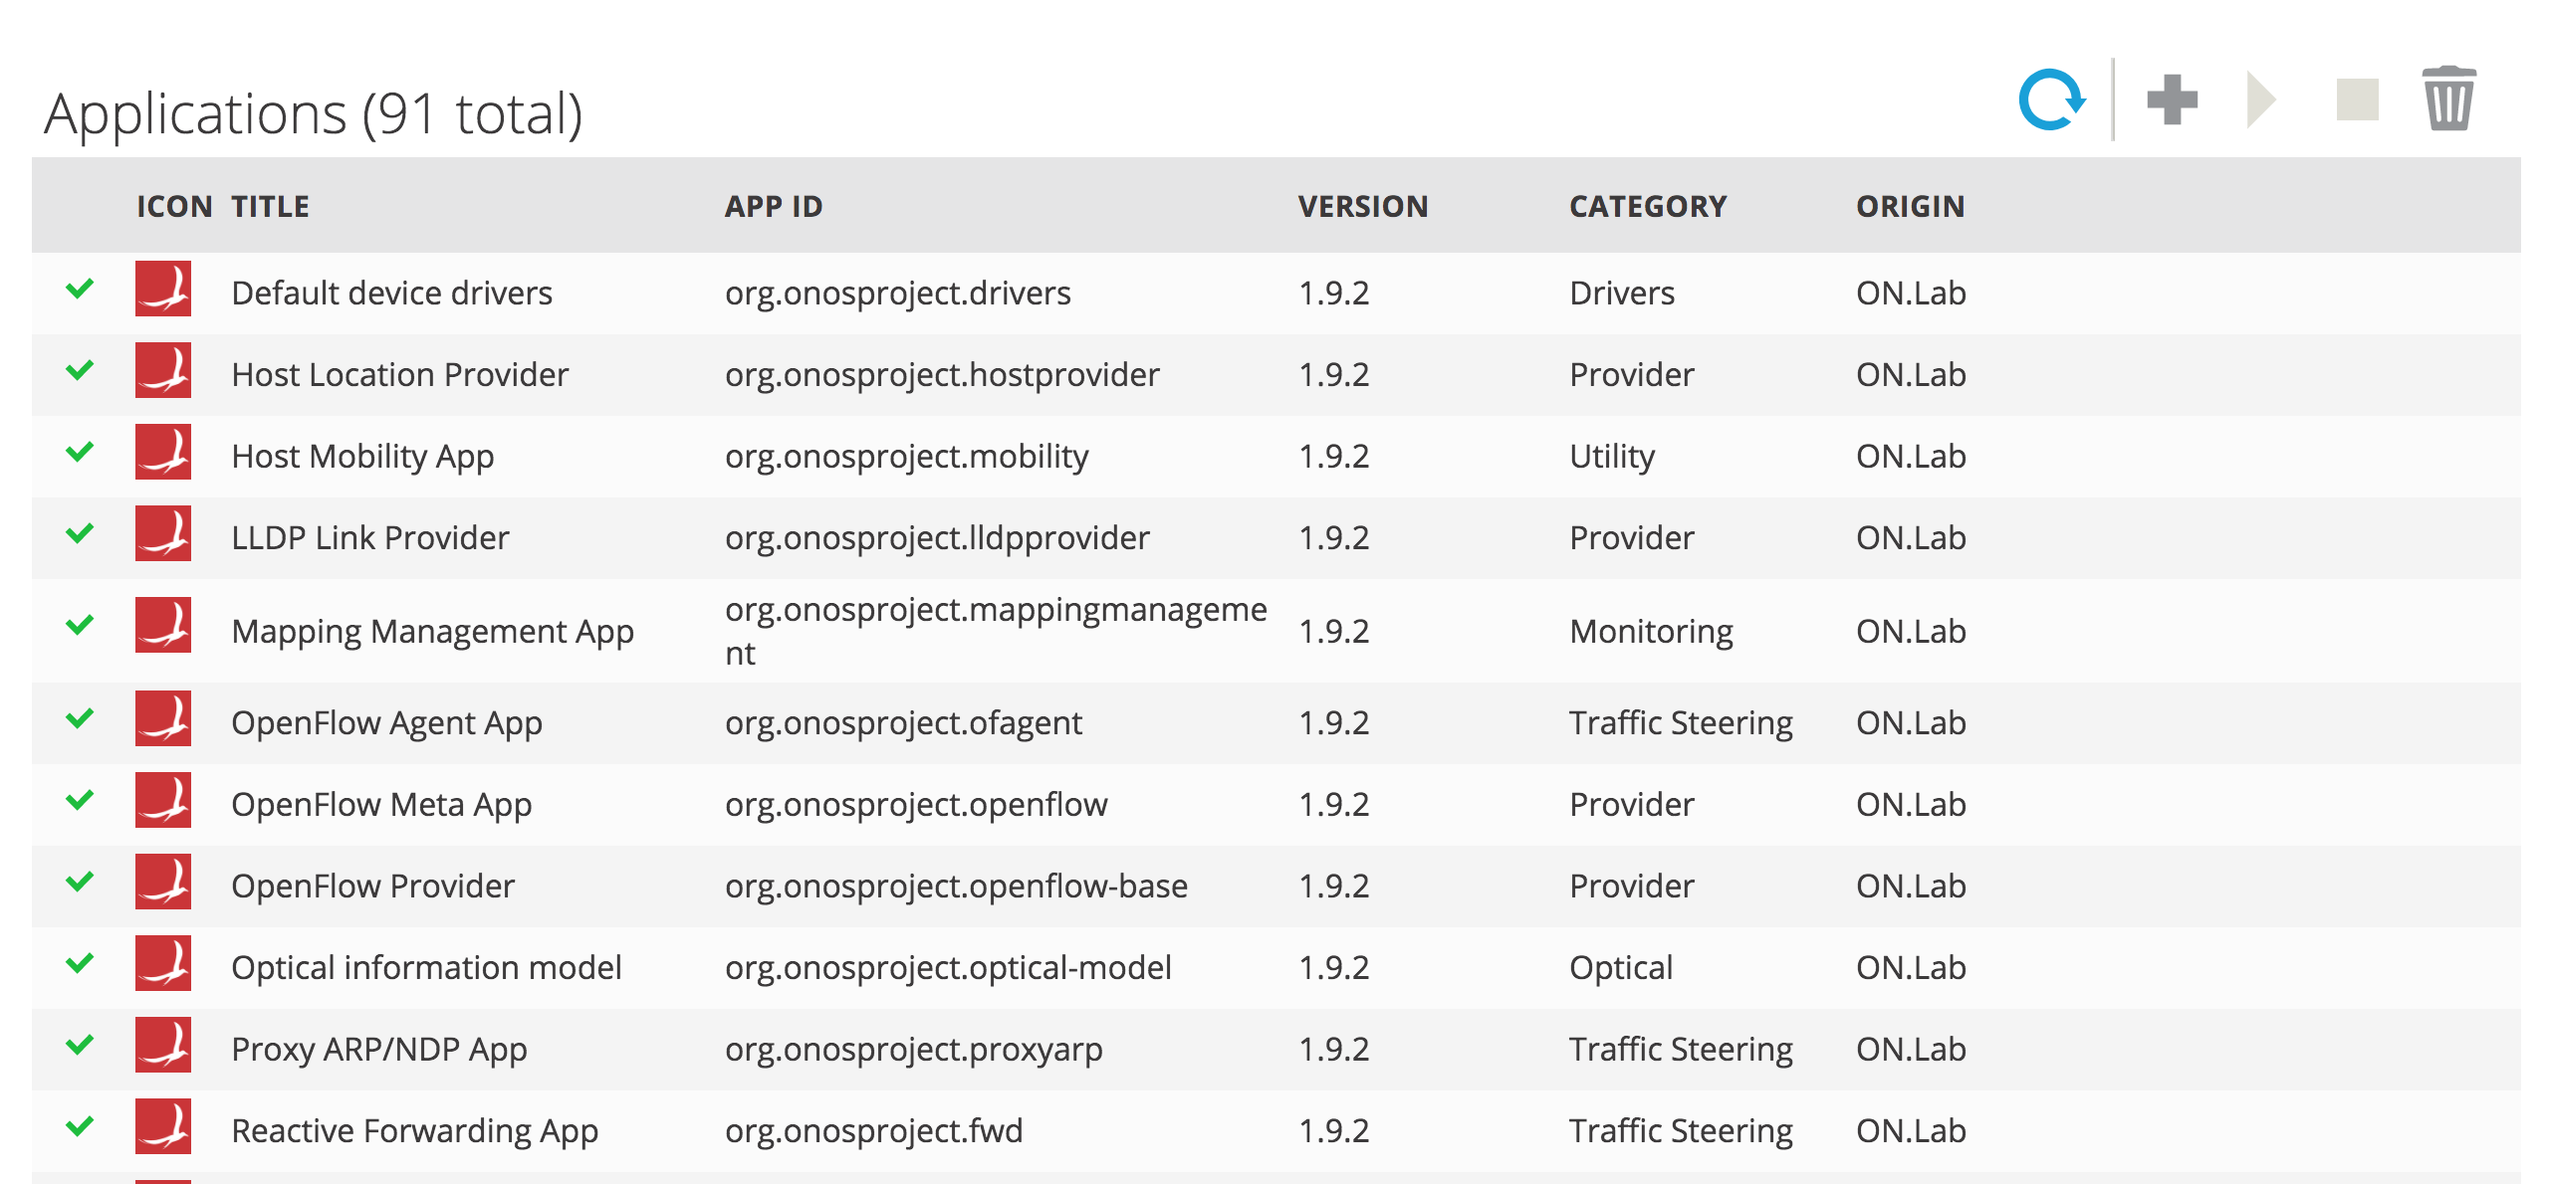

From the Command line, you should see: type “**apps –s –a**”

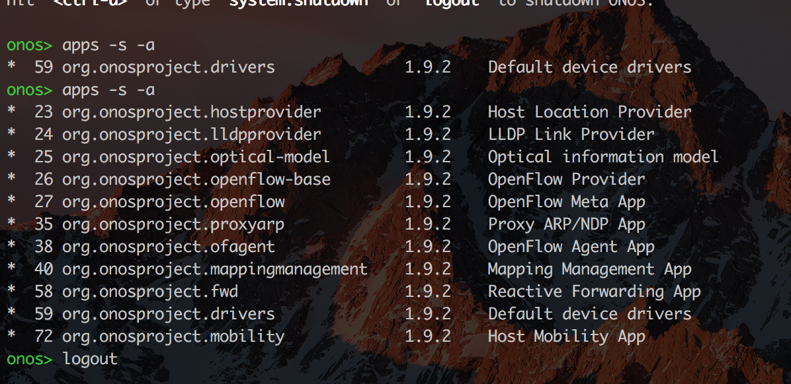

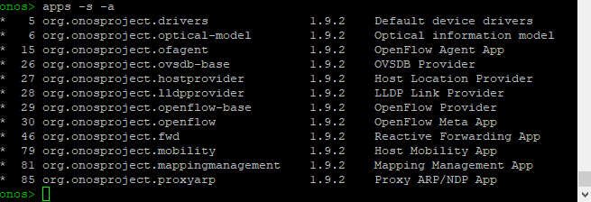

**The initial ONOS setup is complete and we will come back to this VM once we finish configuring our Mininet VM.**

**Installing Mininet:**

**STEP 1**: Login into you VM using vCenter and Note down your IP

**STEP 2**: SSH into your VM using Putty login: student password: dcne123

**STEP 3**: Update and Upgrade the VMs

**STEP 4**: Install git

sudo apt-get git –y

**STEP 5**: Begin Installation

sudo su

git clone git://github.com/mininet/mininet

The above command will download a git repository for the mininet. This repository holds the source code of mininet. Change directory to the mininet git directory which got created after cloning the mininet repo.

Remember git is the version control system which is used to track changes in an application code. Mininet is one such application and it’s various versions are tracked and updated on git. To check the available versions use the following command;

git tag

Paste the following command to create a local branch on your host copied from the version 2.2.1.

git checkout -b 2.2.1 2.2.1

change to parent directory by issuing ‘cd..’ and then install mininet from the script in mininet/util/ directory. Paste the following command to do the same

mininet/util/install.sh -vnf

**STEP 6**: Test if Mininet is working

sudo mn --test pingall

**Note:** “**sudo mn**” creates a basic topology of 2 switches and 2 hosts”

You should see the below output

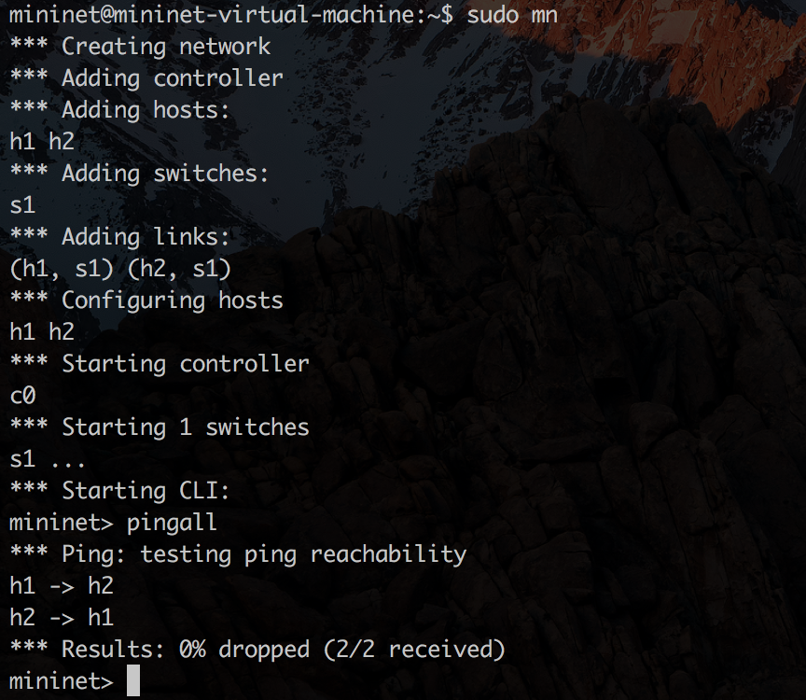

Type “**exit**” to exit mininet

Type “**sudo mn –c**” to clear the topology and cache.

Mininet creates it’s own controller to control the data plane. We will inform mininet to use ONOS controller instead. To do so, Issue the following command;

Sudo mn –controller=remote,ip=xx.yy.zz.ww,port=6633 (replace xx… with your ONOS IP)

You should see the hosts and switches being added in ONOS. Verify this on ONOS GUI.

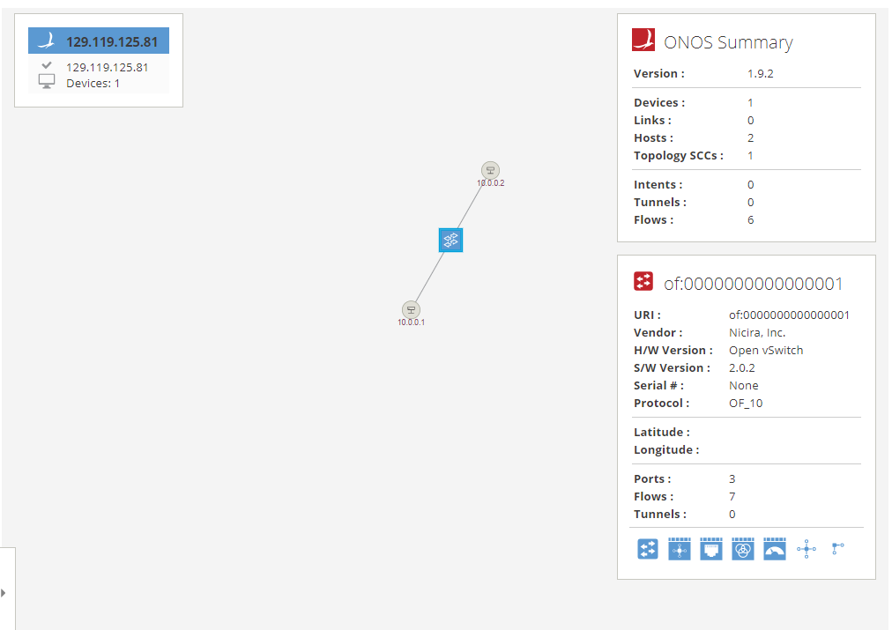

**STEP 7**: Building our own topology using Python

* Create a file named “**triangleTopo.py**”

Type the following code. I screenshotted it so that you can practice typing code ☺

While you type, try to understand the code and see what we’re trying to achieve. It is pretty straight forward.

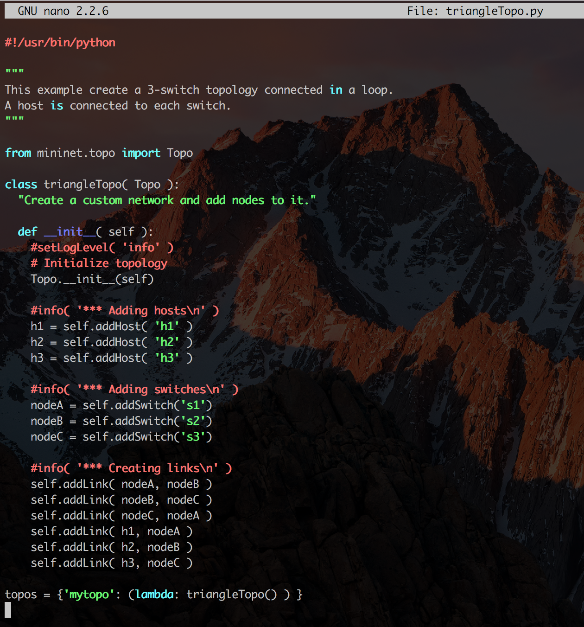

**Step 8**: We will now run our topology and instead of using the default controller in Mininet, we will use the ONOS controller we earlier configured.

Run the below command in Mininet.

**Note**: change the **Bold Text** to the IP of your ONOS VM

sudo mn --custom triangleTopo.py --topo mytopo --mac --controller=remote,ip=**xx.yy.zz.ww**

**type “pingall” to check connectivity**

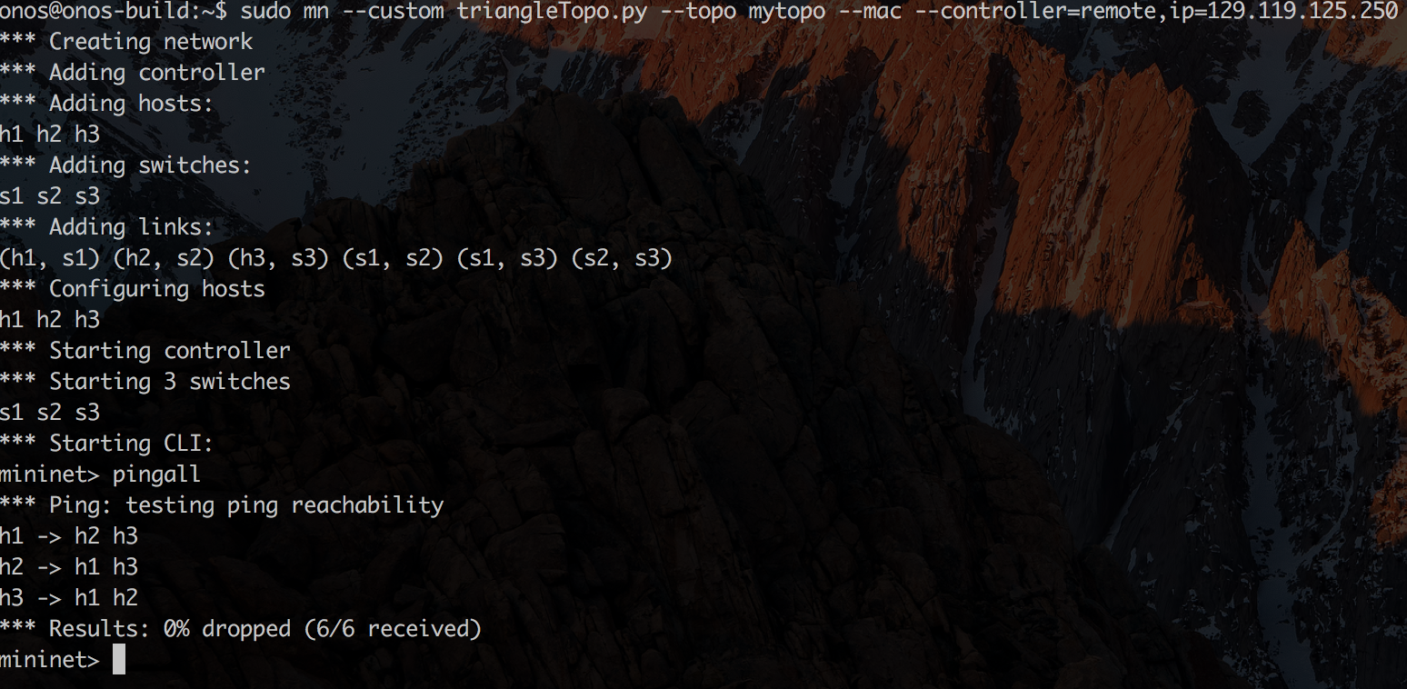

Now check your **ONOS GUI** and you should be able to see your topology of 3 switches and 3 Hosts

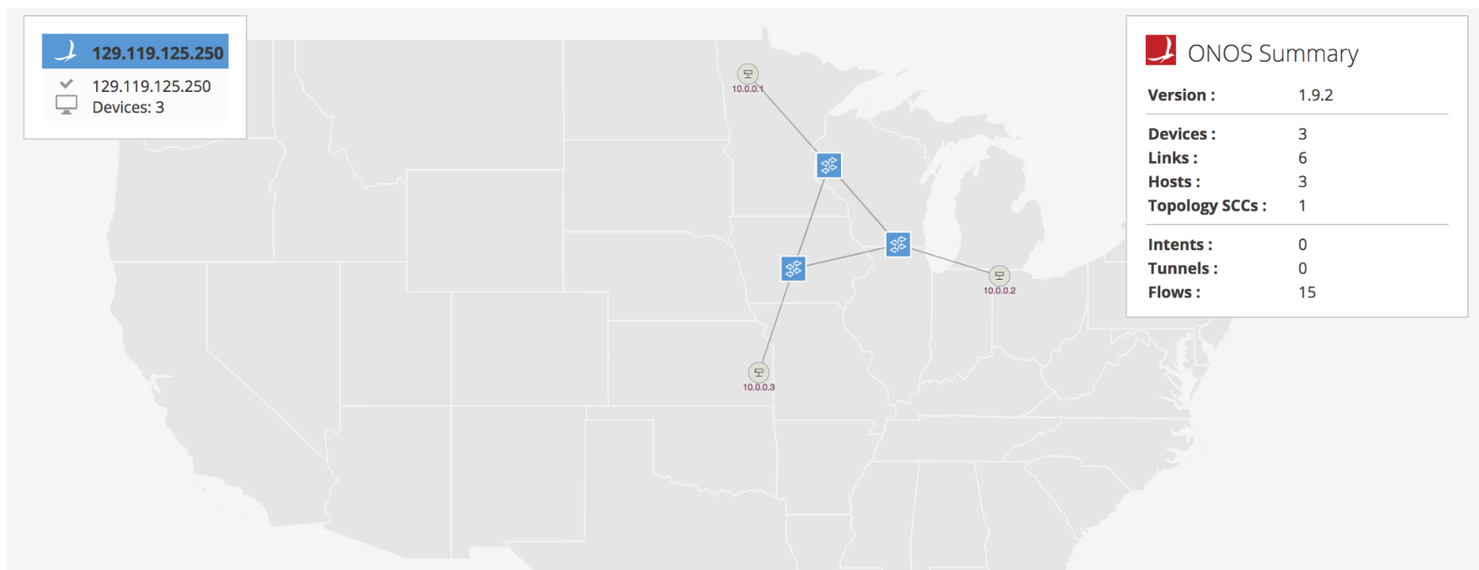

Type **h** to view the hosts

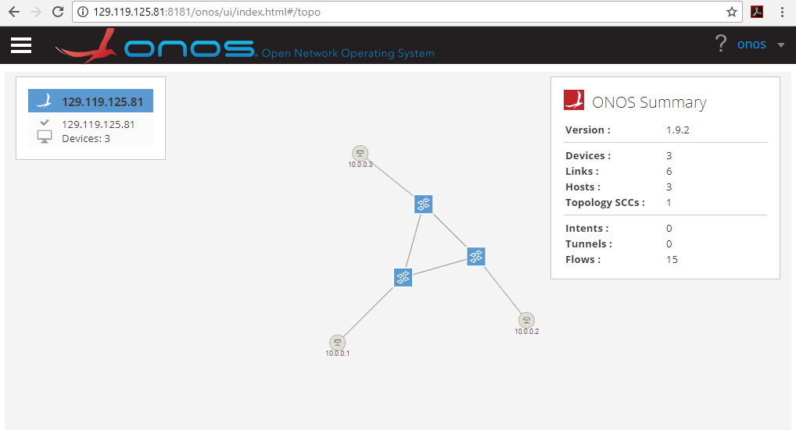

Now you have ONOS and Mininet setup. Now it is your job to go through the command line documents for you to manage and interact with the Onos Controller and Mininet

From the CLI, type the command “devices” to view the switches

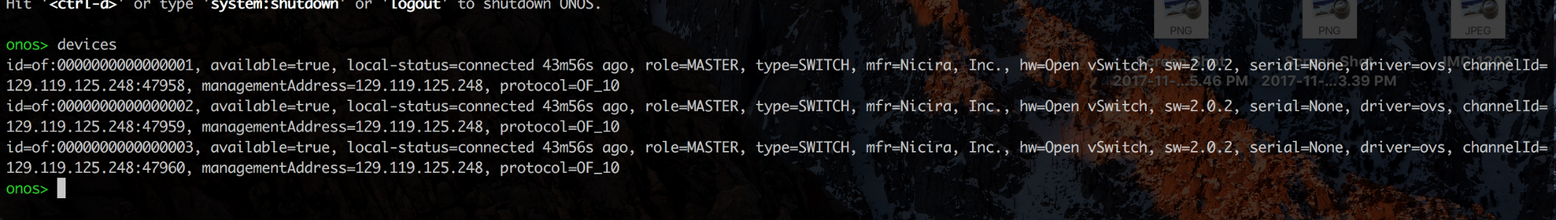

**TASK:**

**Note: Make sure you take screenshots at every step**

1. Create a mininet topology with **5 switches and 5 hosts** using Python and name in **pentagonTopo.py Hint: All you have to do is modify the existing python code**

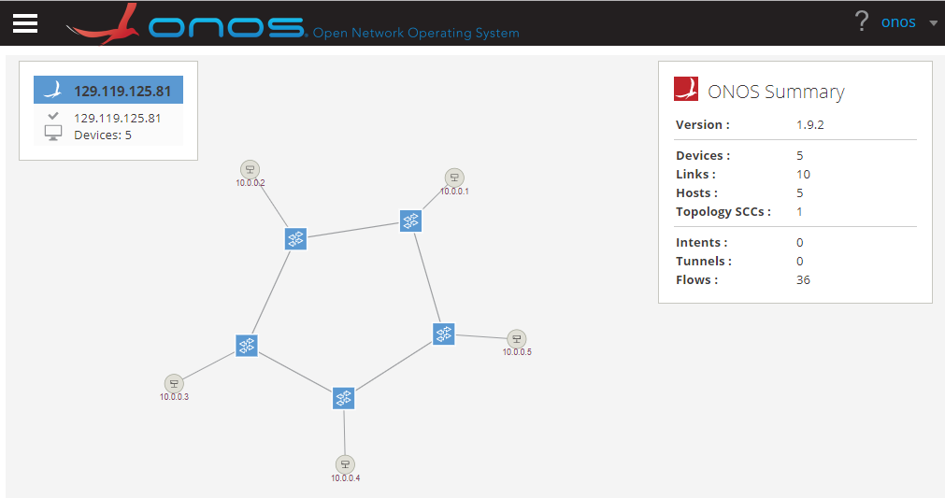

1. Run the topology with the remote Onos controller

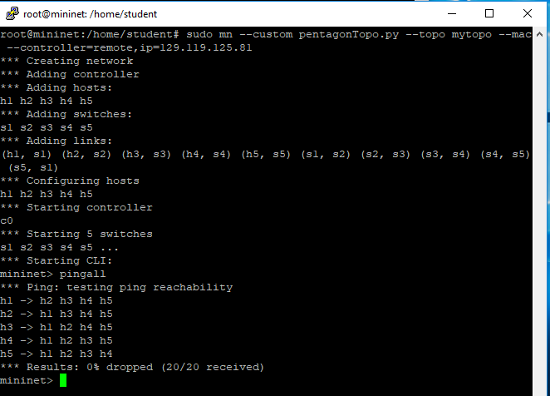

1. View the topology in the GUI and with the “devices” command in the CLI

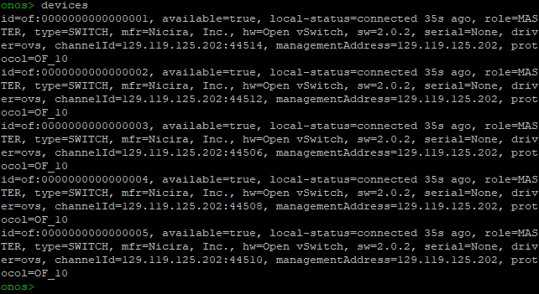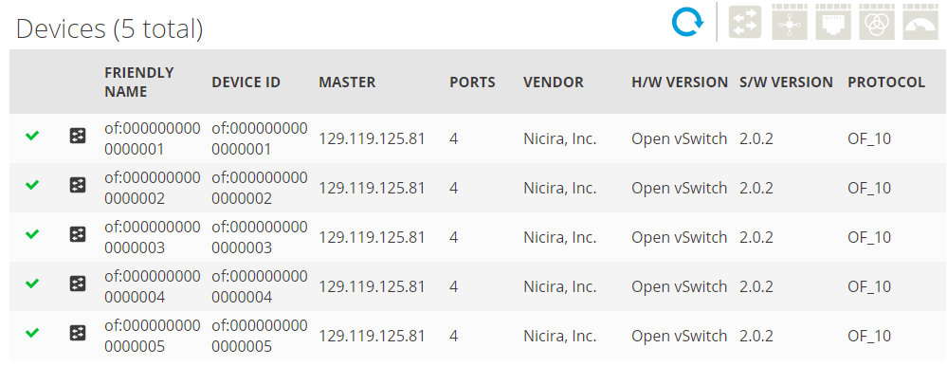

1. In onos take a screenshot of the “links”, “flows” “hosts” command

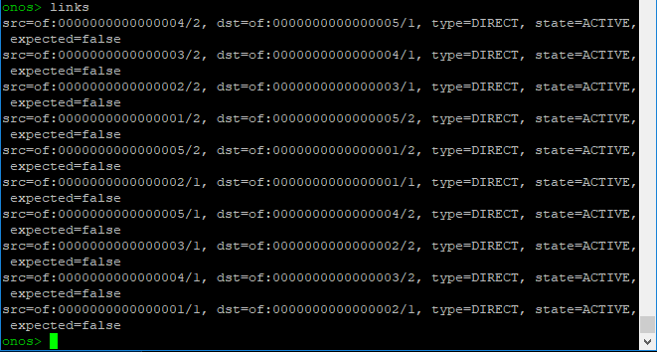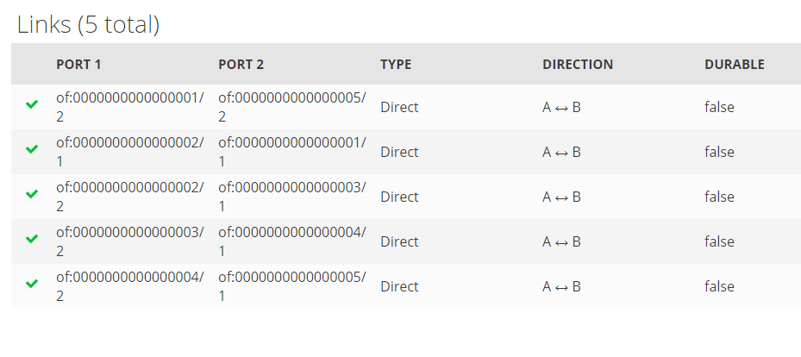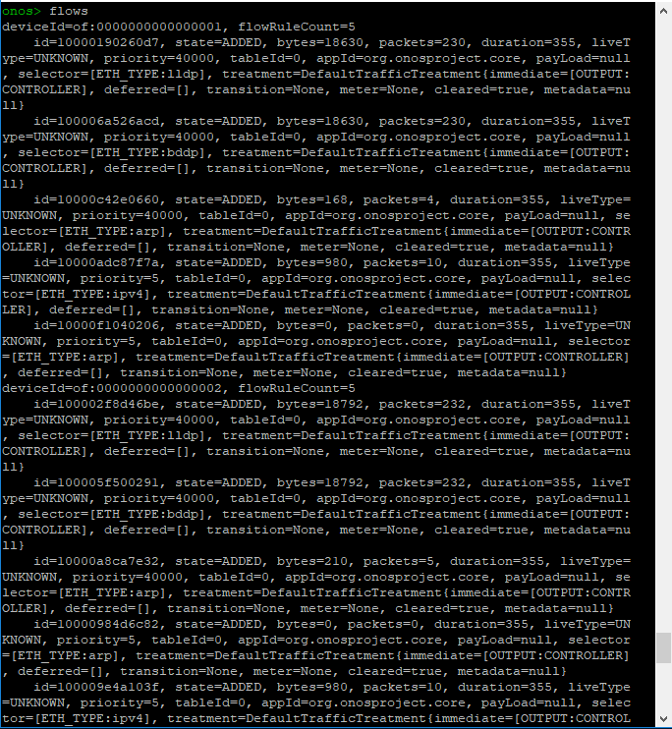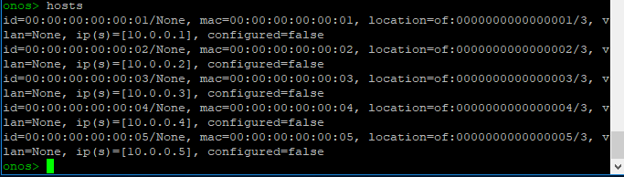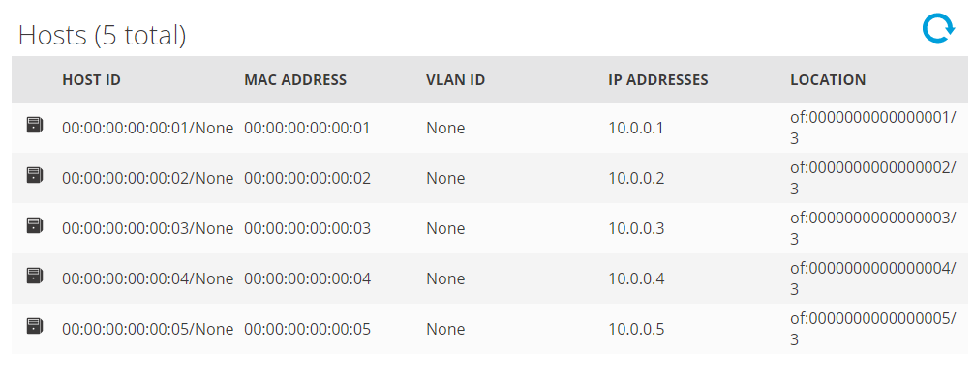

1. Explain in **Detail** what every value in the “flows” command describes.

The flows command lets to see which flow entries are currently registered in the system. Flow entries are in several states:

* PENDING_ADD - The flow has been submitted and forwarded to the switch.
* ADDED - The flow has been added to the switch.
* PENDING_REMOVE - The request to remove the flow has been submitted and forwarded to the switch.
* REMOVED - The rule has been removed.

ONOS gives many details about the flows at the switches. For example, each flow entry defines a selector and treatment which is the set of traffic matched by the flow entry and how this traffic should be handled. Each flow entry it tagged by an appId (application id), this appId identifies which application installed this flow entry. This feature helps an admin identify which application is misbehaving or consuming many resources.

1. Ping between H1 to H2 on Mininet and take a screenshot of the flows in Onos

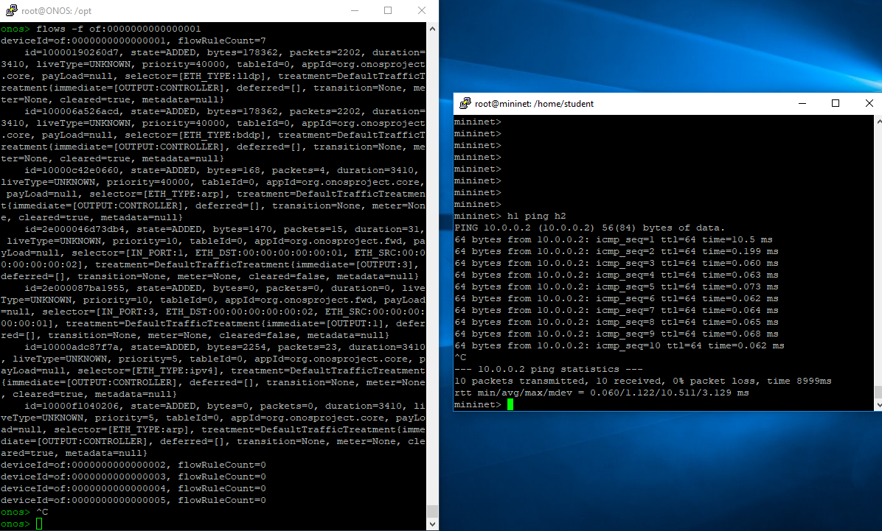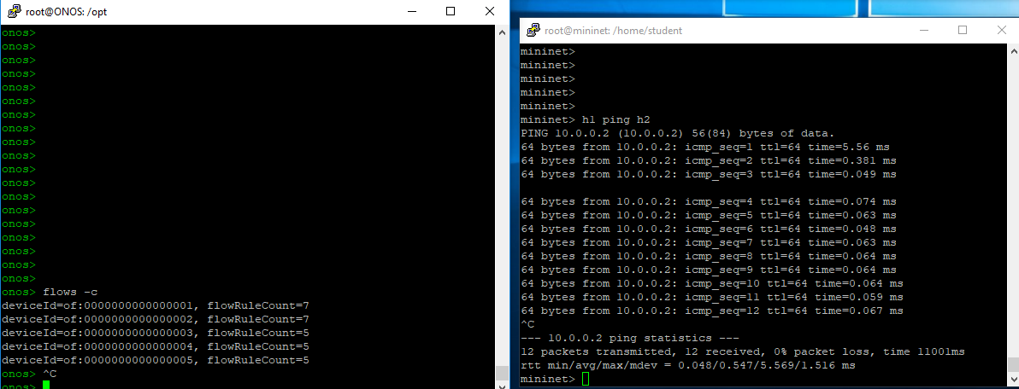

1. Ping between H3 to H4 and do the same

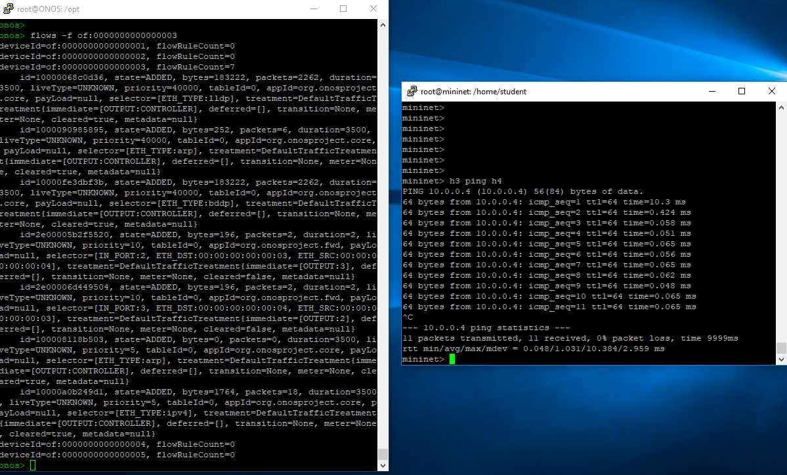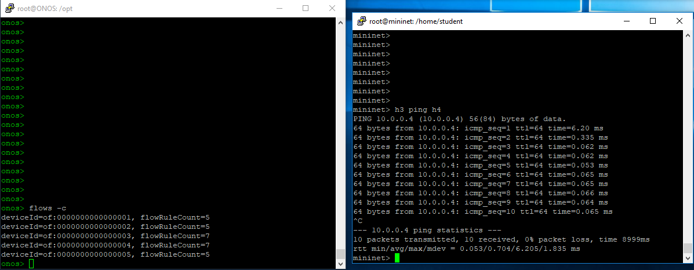

**Resources:**

**Videos:**

1. Intro to SDN <https://www.youtube.com/watch?v=DiChnu_PAzA>
2. SDN and Openflow overview <https://www.youtube.com/watch?v=l-DcbQhFAQs>
3. Introduction to Mininet <https://www.youtube.com/watch?v=jmlgXaocwiE>
4. Introduction to Openflow <https://www.youtube.com/watch?v=l25Ukkmk6Sk&t=2s>
5. Onos Getting Started <https://www.youtube.com/watch?v=LFeOy0PR7VE>

**Documents:**

1. <https://qmonnet.github.io/whirl-offload/2016/07/08/introduction-to-sdn/>
2. <https://wiki.onosproject.org/display/ONOS/Basic+ONOS+Tutorial>
3. <http://mininet.org/>